1] Column Chart:

The column chart comparing marks of different classes like math, science, marathi
Column chart used to compare different item
Easily indentify ligher or lower
Show clearly Difference: show in horizontal
For example : marks different classes ,sales different years, product

Google Chrome.lnk

2] Doughnut Chart:
Show the contribution to the total grade

(1st A grade,
2nd B grade,
3rd C grade,
4th D grade)
The blue portion the largest (quarter sale jast ahe)
The red portion is scend place
And green and purple portion are samaller (sales donhi madhe kami ahe
Seprated space use to attract attention
Data distributed in Doughnut according percentage or other data up to 100%

I have taken this digram from Microsoft word and info collected From ChatGPT
3] Pie chart:

Pie chart means full circle 100% and percentage of part
All way over all distributed data
Categorical means group into categories
Like example colors(red,blue,purpule, green)
Gender(male,female)
Sales Market (which company is largest or lower)
Share market
In the figure color represent different quatrer

https://www.cuemath.com/data/pie-charts/

4] Line Chart:
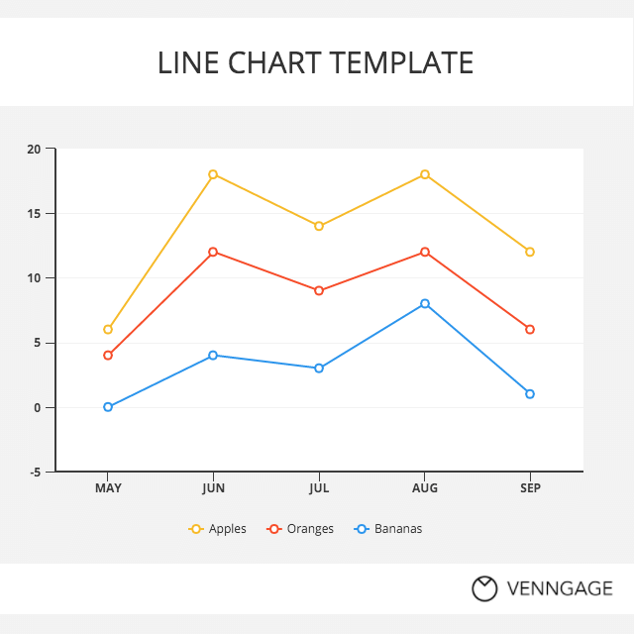
Show in trending data and actual value
Total can change the data
Show trends over time ,display increase or decrease data
Like examples:
Sales ,temperature ,growth

https://venngage.com/

5] Bar Chart:
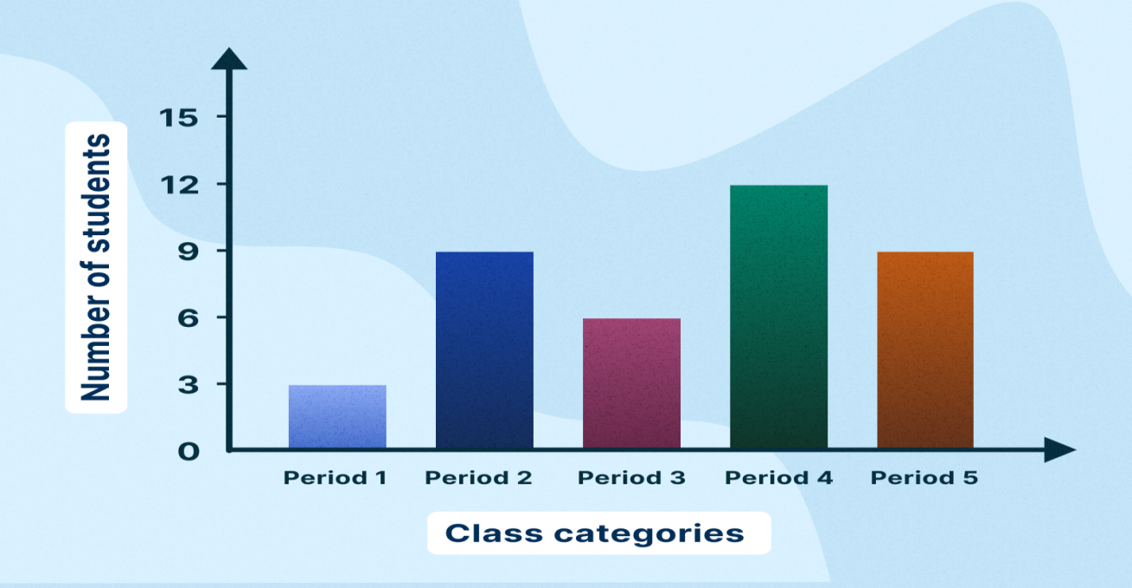
Horizontal barbbbbarbar al
Vertical bar
X axis

Y axis a=axis
Compare different categories using horizontal bars
x-axis = class categories
y-axis = number of students(0,3,6 up to 15)
period1= lowest students
period4 = highest students
Bar chart used to compare categories
Maximum and minimum quickly indentify
And this bar chart make info easy to understand
For example : school result
Different categories data

https://animalia-life.club/qa/pictures/ i have also used ChatGPT and Google for reference
6] Area Chart:
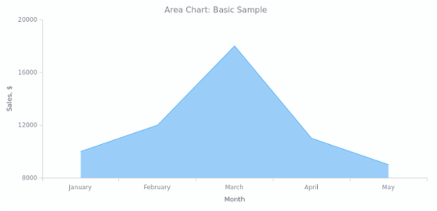
Vertical line
Show sales

Quikly identify minimum and maximum just like bar chart
Horizontal line
Shows Moths
Look for the highest part and lowest part
This bar change over time
Grwoth ,Increase, Dicrease As per
Like example: School sports day diff Houses(as per colors)
Mobaile data used

docs.anychart.com

7] Scatter Chart
Scatter chart means one data point
Used dots to show data
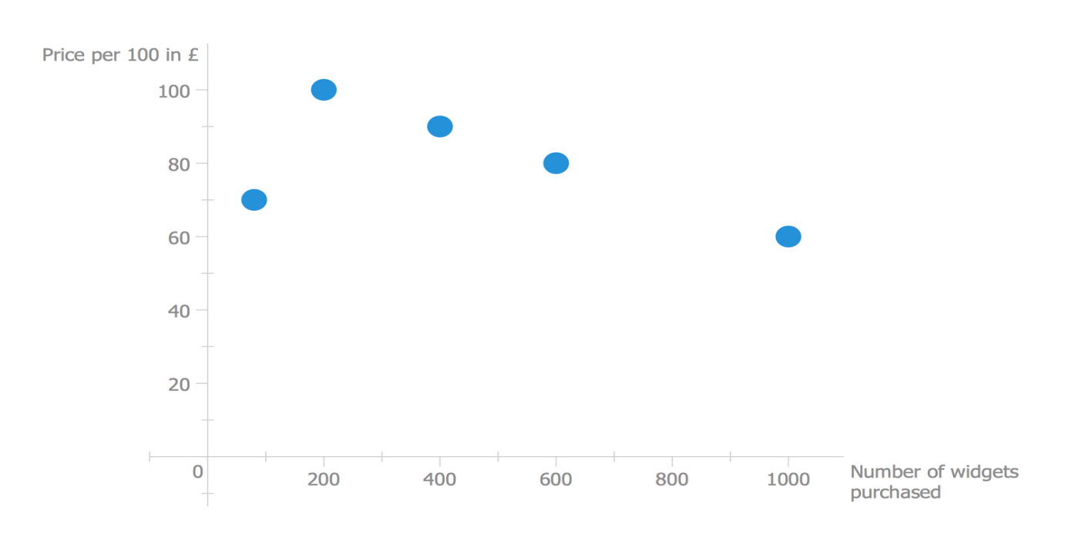
Scatter chart used show relationship between two numbers

www.conceptdraw.com

8] Stock Chart (Increase and Dicrease price)

Stock chart means show share price movement
1 Open: starting price of the day
2 High : highest price of the day
3 Low: Lowest price of the day
4 Close: closing price at the end day
Used stock market, trading, investment me

I have taken this digram from Microsoft word and info collected From Gemini

9] Waterfall chart:
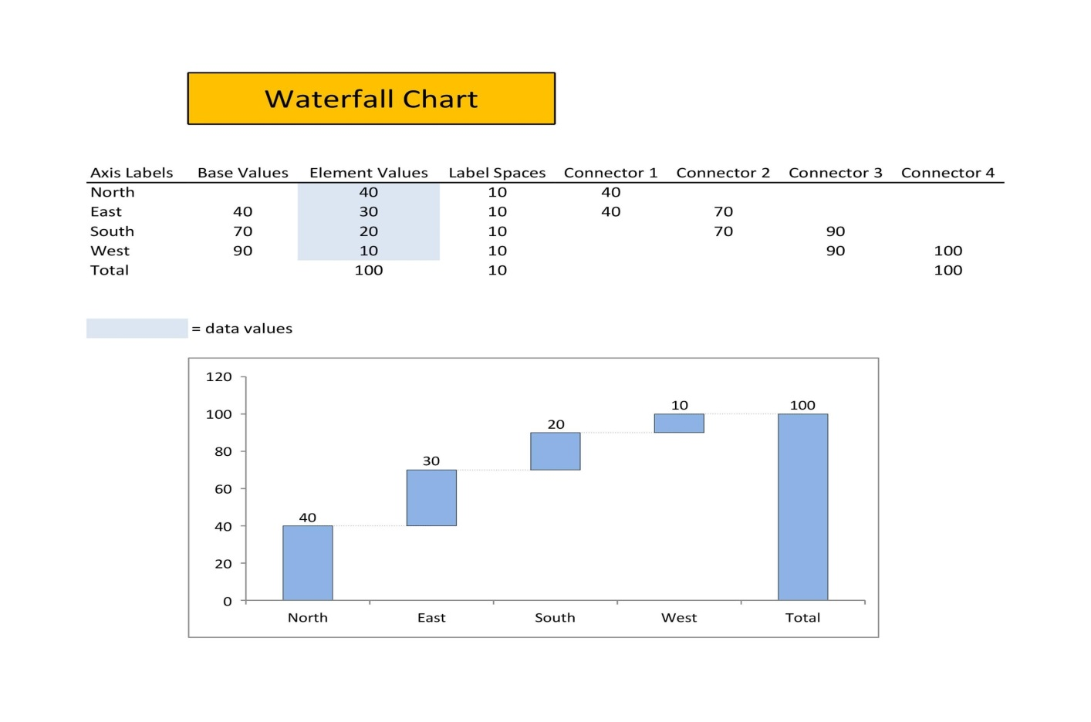
Water fall Chart is starting value increase or decrease step by step and see final value
And it is call a waterfall because it look like waterfall
Why the bars look like flowing down
in figure 1st bar North next bar increase decrease ho raha hai and last final total
used to show profit changes step by step

https://templatelab.com/waterfall-charts/
read from different sources and wrote it in my own words.”
10] Histogram chart:
Number of people
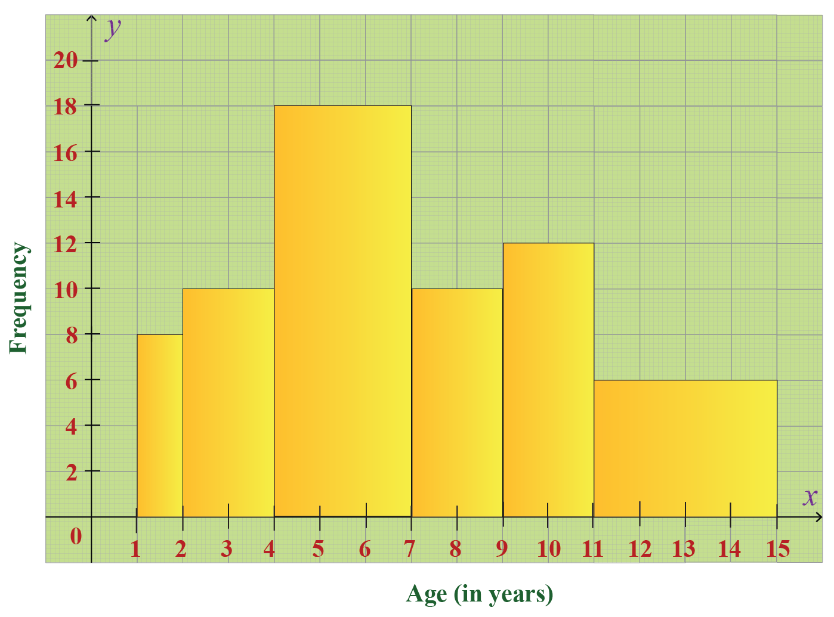
Age groups

What is shows most people are 4 to 7 years
And few people 11 to 15 years
This is distribution of age
Used understanding Distribution

www.cuemath.com
read from different sources and wrote it in my own words.

11]box & whisker chart:
Between Q1 and Q2 Show the middle 50% of data
Whisker means lines
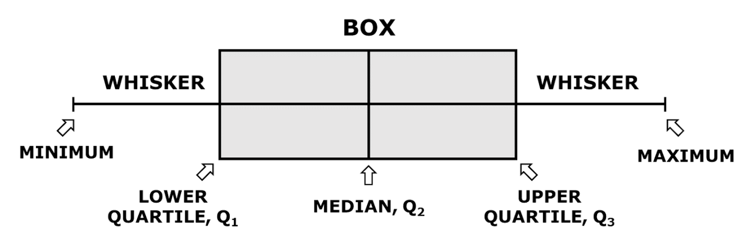
Smallest value Of data
Largest value of data
Middle value data

Box chart used data distribution of compare two groups
finde outliers.
(box data means asa data jo spread jhala ahe he dakhvto)
Box used for educational data Like: Compare marks class A and B

helpingwithmath.com
read from different sources and wrote it in my own words.

12] Sunburst Chart:
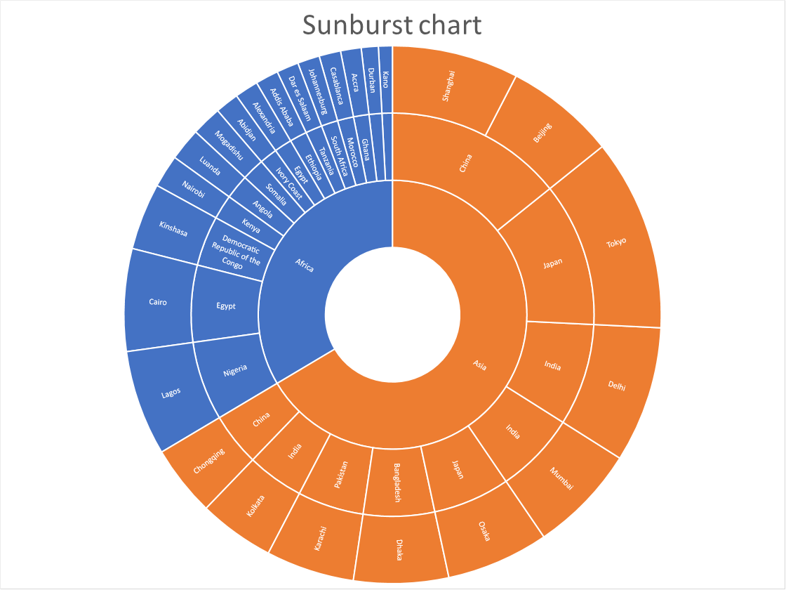
Sunburst Chart is show hierarchical data
Look like circle layers
Center circle – main category
Next ring – subcategory
Last circle – sub-sub category

Like example : parent = child = sub-chaild

https://www.get-digital-help.com/-read from different sources and wrote it in my own words
“I have not copied directly from any website. first i read the information carefully then I wrote it in my own words based on my understanding”

